Guidance, Instructions, and Information on How to Use ClinicalTrials.gov

- The PI (Responsible Party) is to request a user name and password from Odette Lobo in the CHA Office of Sponsored Research. Include the following in your email request to her:
  - Your CHA user name
  - Your full name, including degree (e.g., MD, PhD)
  - Your CHA email address
  - Your telephone contact information

- The CHA Office of Sponsored Research will send a profile request to ClinicalTrials.gov.

- The PI should receive an email from ClinicalTrials.gov in 2-4 business days. PLEASE MAKE NOTE OF YOUR USER NAME AND PASSWORD.

- The PI can now login to the ClinicalTrials.gov Protocol Registration System (PRS):

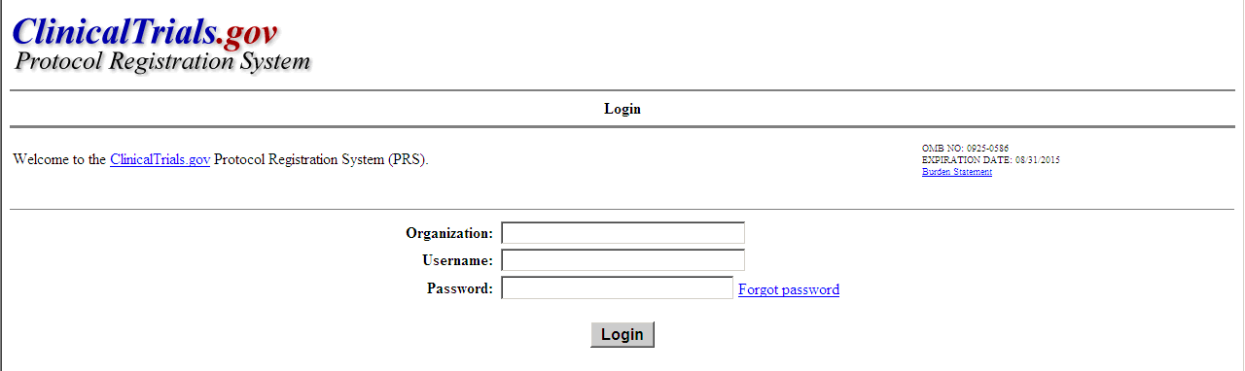

- CHA’s Organization name is CambridgeHA.

- Enter your username and password.

- In the application process, the “Board Name, Board Affiliation, and Board Contact” are as follows:
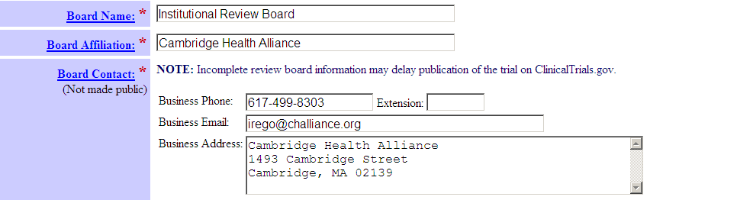

- Location/Facility should always be listed as Cambridge Health Alliance, not Cambridge Hospital, etc.
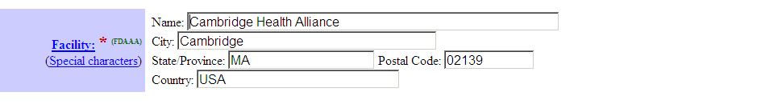
- Your best and quickest resource for more information on the following is ClinicalTrials.gov:

  - How to Register Your Study
  - How to Edit Your Study Record
  - How to Submit Your Results
  - Support Materials
  - Training Materials
  - Frequently Asked Questions

