 | ASSENT FORM  8 – 10 years old
Participant’s Name :

Today’s Date:

Home Address:

Name of Investigator:

Title of Study:



My name is . We would like to talk to you and your parents/guardians about you being in a study we are doing.


We are looking to find out how will work on kids.


We would like you to take part in this research study because .
You do not have to say “yes”. We will not punish you if you say “no”. No one will be mad at you if you say “no.” It’s your choice if you want to be in this study.
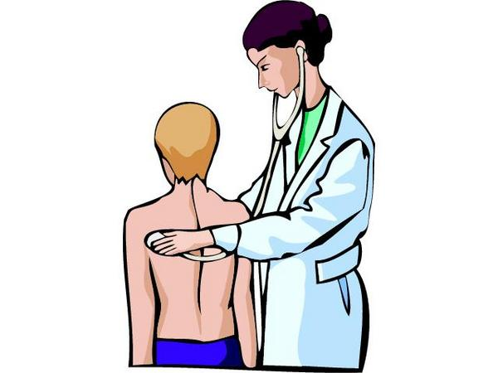
We will start by

☹

If you take part, the bad things that could happen are

☺
If you take part, the good things that could happen are


If you take part, we will give you


If you don’t understand anything, ask one of us to tell you more about this study or


If you have any questions, you or your Mom or Dad call us at


If you would like to take part in this study, please check the box and sign your name:

❒ Yes, I will take part in the study.

❒ No, I do not want to take part in the study.

Signature of Child

Printed Name of Child

Signature of Person Getting Assent

Printed Name of Person Getting Assent

Date

Attachment

IRB Authorization

This page confirms that this study has been approved by the Cambridge Health Alliance IRB. The IRB is a group of people who are responsible for protecting the safety and welfare of people who take part in research studies at our hospital.

Title of Study:

Name of Principal Investigator:

IRB No.:_____________________

IRB Approval Date:____________________

IRB Expiration Date:___________________

STAMP HERE

