A Patient’s Guide to Recovering from COVID-19

Prevention is Key!
- Wash your hands: Protect yourself and others by washing your hands often with soap and water for 20 seconds, or hand sanitizer.
- Avoid contact with people who are sick. Stay home if you are sick.
- Avoid touching your eyes, nose, and mouth.
- Cough/sneeze into tissues, your elbow or your shoulder.

Manage Social Isolation
- Structure your days: Working from home? Stick to your normal work hours, start the day by changing into work clothes, change back into relaxed clothes after your work hours. Not working? Find new hobbies.
- Connect and communicate: Social isolation is challenging! Stay connected through phone calls, video calls, or social media to engage with family/friends.
- Make a comfortable space: Clean up clutter and set up plants, art, and furniture in a way that makes you feel safe, happy, and calm.

Healthy Eating Habits
- Eat a well balanced diet which includes fruits and vegetables of all different colors.
- Avoid alcohol as it can poorly affect your sleep.

Get a Good Night’s Sleep
- Avoid blue light for 1 hour prior to bedtime by turning off your electronic devices.
- Consider meditating prior to bedtime with the help of guided meditation apps, try Calm.
- Go to bed at the same time each night. Aim for at least 7 hours of sleep.

Improve Your Mental Health
- Exercise. Dance, walk, jog, strength train, stretch, do yoga. You can follow the exercises in this guide.
- Distract yourself. Read a book, draw, paint, knit. Try something new!
- Limit your news feed. Disconnect from news and social media to refocus.
- Be gentle with yourself and others, and reach out to those you care about.

Mental Health Resources
Many people require emotional support in these circumstances. These resources are available to help you:

- SAMHSA 24-hour Disaster Distress Helpline at 1-800-985-5990 or text 66746 (English and Spanish).
- Text HOME to 741-741 from anywhere in the USA to text with a trained crisis counselor.
- National Suicide Prevention Lifeline 800-273-TALK (8255) https://suicidepreventionlifeline.org
- NAMI (National Alliance on Mental Illness) HelpLine
  - Monday-Friday, 10:00 am to 6:00 pm, EST (800) 950-6264
- CHA Center for Mindfulness and Compassion – free daily online practice in English, Spanish, and Portuguese. https://www.chacmc.org/connect
- You may also call your primary care physician, physician assistant, or nurse practitioner to express your feelings.

Physical Exercise
- Walking: During your recovery period we encourage you to walk, even if at home, to improve your overall conditioning.
  - Week 1: 5 minutes, 5 times per day.
  - Week 2: 10 minutes, 3 times per day.
  - Week 3: 15 minutes, 2 times per day.

- Positioning: Spending many hours on your back can lead to deconditioning and other problems. We recommend sitting upright as much as possible, walking around as able, and changing positions regularly. Some patients have an easier time breathing on their stomachs with a pillow under their chest to open up different parts of the lungs.

Exercise Precautions
- STOP exercise immediately if you experience chest pain, palpitations, exhaustion, or dizziness/lightheadedness. Contact your health care provider or 911 promptly if these symptoms persist.

Home Exercise Program

- Aerobic Exercises (Cardio)

Purpose: To improve oxygen delivery by strengthening the heart and improving lung function.
Which aerobic (cardio) exercises can I do?
- Walk
- Warm-Up: Walk at an easy pace for the first 5 minutes
- Exercise: Walk at a moderate pace for most of your exercise session.
- Cool-down: Walk at an easy pace during the last five minutes.

How much aerobic (cardio) exercise do I need?
  - Start small and slowly build up your endurance. For example, start with 5 minutes, 5 times each day.
  - Slowly increase to 30 minutes or more per day, 5 days per week.
  - If you are unable to exercise for 30 minutes in one session, you can do multiple smaller sessions of 10 minutes or longer throughout the day. For example, three 10-minute sessions per day.

How hard should I exercise?
- Maintain moderate intensity – slightly heavy breathing, can still carry out conversation.
- Slow down if your breathing becomes labored and you can no longer maintain fluid conversation.
- Stop and rest if you are short of breath.
- Don’t walk so far that you can’t get back to your starting point without difficulty.

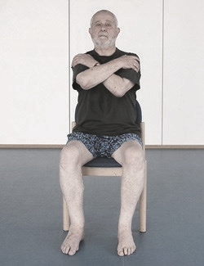
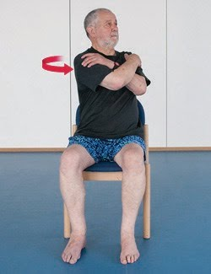
2. Flexibility Exercises (Stretching)

B
A

Trunk Twist
- Sit upright with feet flat on the floor, cross your arms and reach for your shoulders.
- Without moving your hips, turn your upper body to the left as far as is comfortable.
- Hold for 20 seconds and then relax your body. Repeat 5 times.

3. Strengthening Exercises

How much strengthening exercise should I do?
  - Perform each exercise 2-3 times per week
  - Start by doing 8 repetitions per exercise
  - Gradually work up to 15 repetitions per exercise
  - Once you are able to comfortably do 15 repetitions, try to add a second set of 15, and eventually a third set. Allow 1 min break between sets.

Sit to Stand 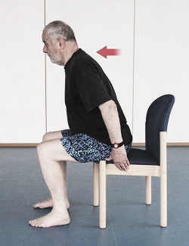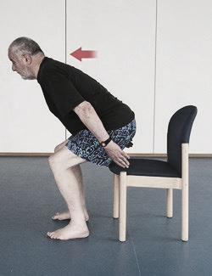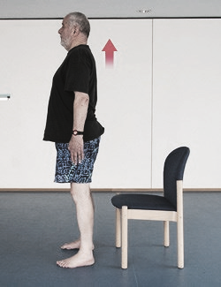

A
B
C
- Sit on the edge of the chair, feet hip-width apart. Lean slightly forwards.
- Stand up slowly, using your legs to lift up (try not to use arms to push up if able). Keep looking forwards, not down.
- Stand upright before slowly sitting down, bottom-first.
- Breathing: exhale as you stand up and inhale as you sit down

Leg Swing
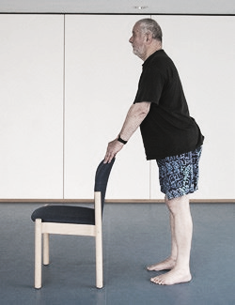
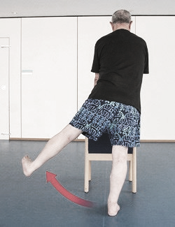
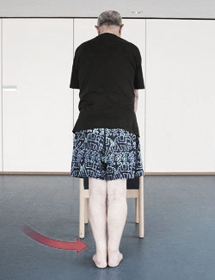
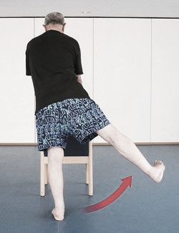

A
B
C
D
- Rest your hands on the back of a chair for stability.
- Raise your left leg to the side as far as is comfortable, keeping your back and hips straight. Avoid tilting to the right.
- Return to the starting position.
- Now raise your right leg to the side as far as comfortable.
- Breathing: exhale during the out swing and inhale as you bring the leg down

Wall Push Up
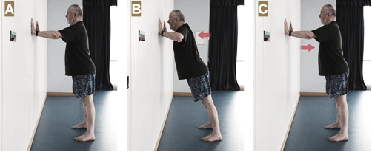
- Stand at arm’s length from the wall. Place your hands flat against the wall, at chest level, with fingers pointing upwards.
- With your back straight, slowly bend your arms, keeping elbows by your side. Aim to close the gap between you and the wall as much as you can.
- Slowly return to the start.
- Breathing: exhale as you push away from the wall and inhale as you move toward the wall

